Vetwork UK Veterinary support visit to Pets Welfare Association, Lesotho. February 2015

Quotes of the trip:

“Do your children go to school?”
“Yes but it was blown away by a heavy storm.”

“What are your donkeys called?”
“We call them...’the donkeys’”

The visit focused on the Quabane Valley district in southern Lesotho. This is an extremely remote region with no electricity or indoor plumbing to any households in the region. After crossing into Lesotho at Quacha’s Nec we had a further hour on Tarmac road (part of which was only laid 3 years ago) and another hour on hard-to-negotiate dirt tracks before reaching the household of our host Lekena Bereng, co-founder of PWA Lesotho. The last few miles of dirt-track road to our destination at Ha Mohlokane were so challenging that our driver opted out of the opportunity to collect us at the end of the trip so we were dependent on the local “taxi” network from that point.

The area we worked in is one of contrast and challenge. Stunningly beautiful mountain scenery, not unlike the English Lake District (but with deep river gorges, rather than lakes, prevailing) with a parallel landscape of short cropped grass, outcrops of aloe and scrub with very few trees, testifying to a local economy highly dependent on grazing animals (cattle, sheep, goats, horses and donkeys all abound). The sheep folds, manufactured from blocks of local stone, with their small (sheep sized) entry points, facilitating easy closure and defence from predators also had marked parallels with traditional Cumbrian construction. In Lesotho these are still very much a part of routine flock management, essential for protection of the small herbivores at night, mainly from predation by jackals.

Sheepfold in the hills
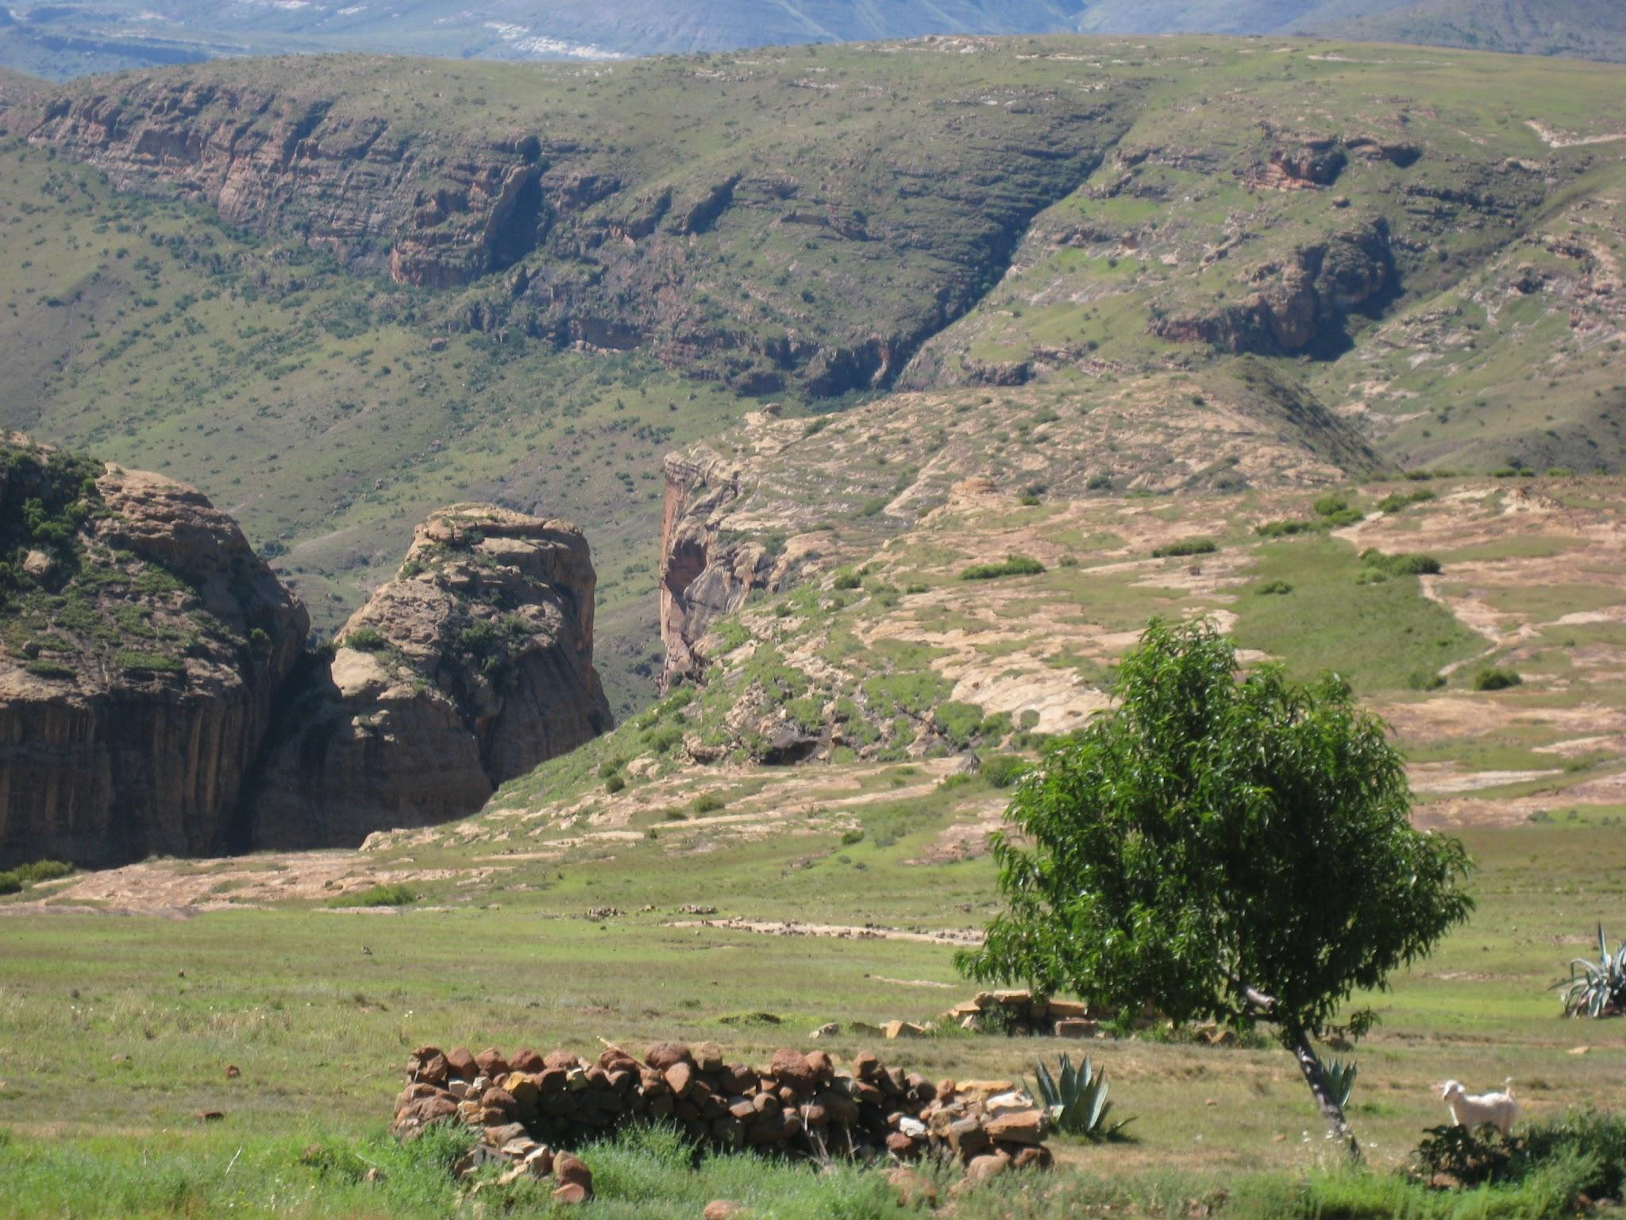

Shepherds sporting traditonal Basutho blankets
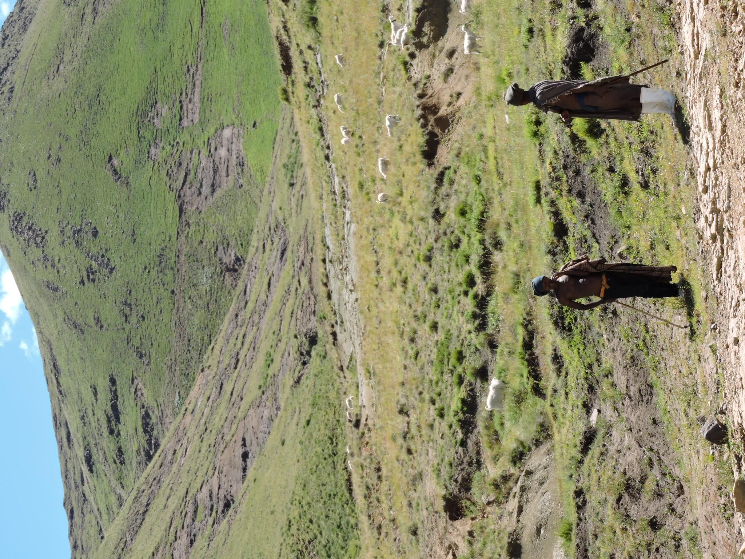

The area exemplifies subsistence living in a stable environment. The community is highly interdependent on animals for transport, food, income, rodent control and security. Ironically despite the number of animals that abound here there is no input into animal health and welfare from either the state or the private sector at present, hence huge potential for vets to have a positive impact in the area. The present situation is that a large number of herbal remedies are still used for both animals and people. (Appendix 1). If veterinary drugs are required then this necessitates a trip into South Africa to purchase them in Rand, but antibiotics, vaccines and other requirements are readily available from pharmacies in Matatiele (nearest town in SA) for ready money. Treatments for sheep scab, Anthrax and Rabies vaccine are some of the commonest drugs required.

Equines are still an essential part of the transport network in this country. The tarmac road network is minimal and many villages are accessible by horse or donkey only. Donkeys ferry about the ubiquitous 50kg sacks of maize with aplomb. The “horses” (tough, finely built Basutho ponies typically 13-14 hh) usually ferry their owners, usually male but I did meet Momosaquone riding past, a lady with a good command of English. A foal followed closely behind the mare she was riding, a common sight in these parts.

Donkey transport
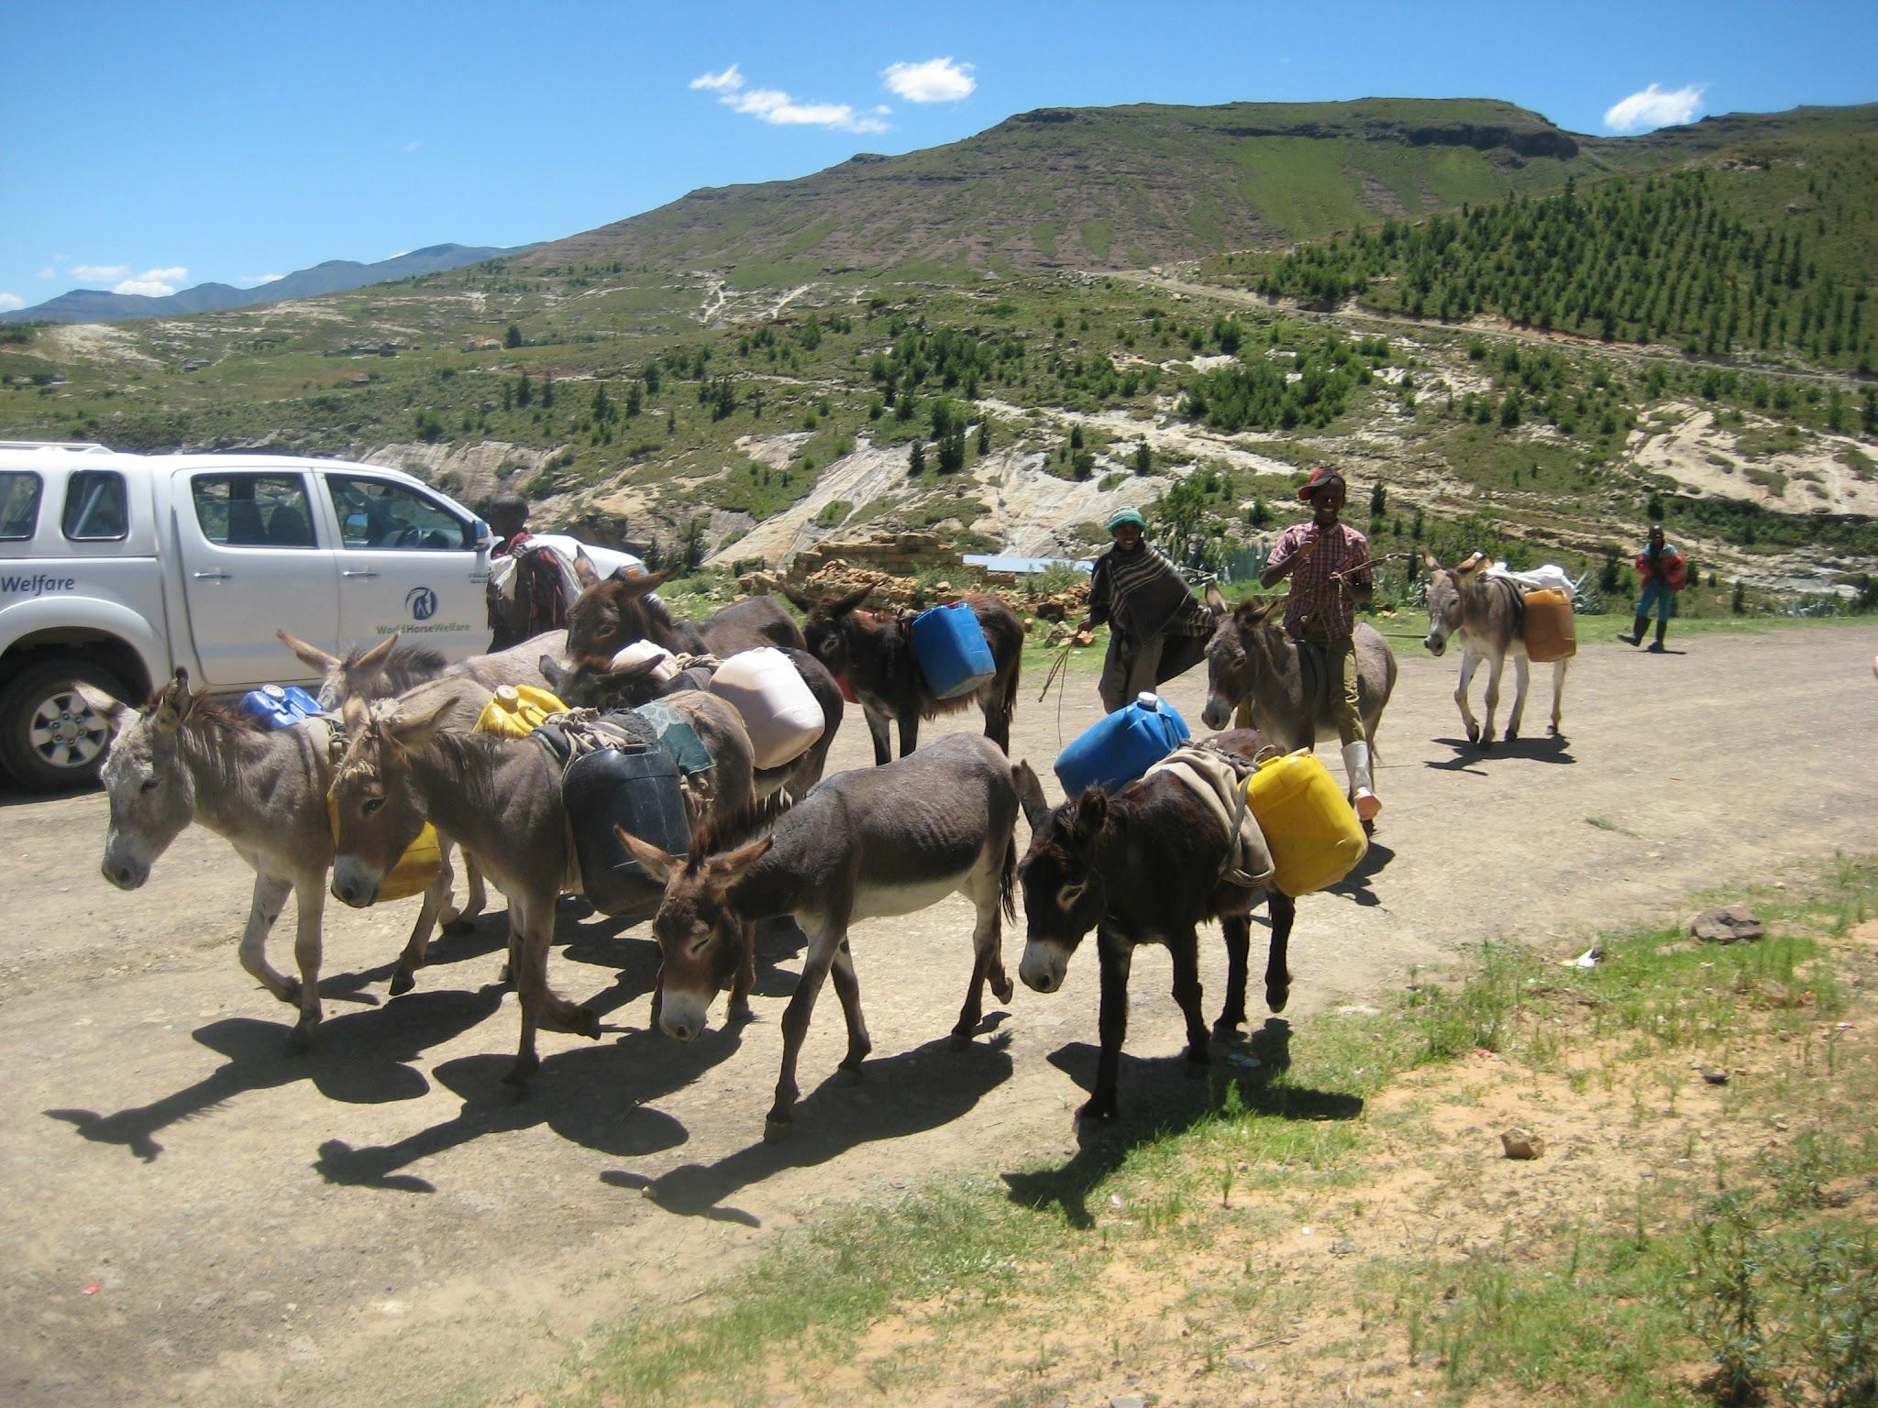

Lekena Bereng, our host and founder of PWA Lesotho has become an excellent advocate and negotiator for his community. His Blackberry provides a link to the outside world. He informed us that this visit was the first to the area by any outside organisation (although I did manage to find evidence of an ODA funded report on the area in 1989, highly likely that Lekena was away in school at the time.). His brother died of AIDS in 2004, leaving 3 children and Lekena cares for this extended family. His achievements include provision of piped drinking water to the villages in Qabane (USAID funding via Christian Relief Services supplying materials and the community supplying the labour) and he has just secured funding from “Friends of Lesotho”, a Peace Corps initiative, to repair the roof of his local school - blown off by a storm 8 years ago. He is currently funded by the Donkey Sanctuary to train at Highveld Horse Unit in SA as an equine inspector, which he hopes will help him further the cause of animal welfare in Lesotho. “There is no animal welfare in Lesotho, only me” he grins. It is important to note that English is not his first language and that he has little opportunity to encounter spoken English, so it can on occasion be difficult for him to fully engage with conversation as he is more familiar with the written word in this language. He is a kind, genuine and shy individual motivated to bring focus and assistance to Lesotho and its problems.

Our first point of call was to meet Mabatho, the chief of the region, remarkably a female chief. This came about because, despite the accession to chief following the same rules on primogeniture as are currently in force in England she became acting chief when her husband, who had been chief, journeyed to CapeTown several years ago. He never returned and so she remains in his stead until his return or her demise. She was born in 1928. I asked her what changes she had seen in her time and she replied with the complaint that formerly people would respect the chiefs and their system of rule but that nowadays people were only interested in politics. As Lesotho’s wealth (mainly diamonds) is in the hands of the politicians every ambitious individual wishes to become a politician to secure power and wealth. Mabatho is much respected in her area for sound judgement and being incorruptible. Once we had her blessing we were able to work unchallenged in her domain. On the walk back we visited the school, one of its three classrooms completely open to the elements following the loss of its roof in a storm, the “kitchen” just a couple of cauldrons covered by a tarpaulin. Children receive a lunch provided by food aid, principally ‘pap’ ie maize meal, staple diet in Southern Africa. This school is state funded, but the teachers are unqualified.

Classroom “al fresco”
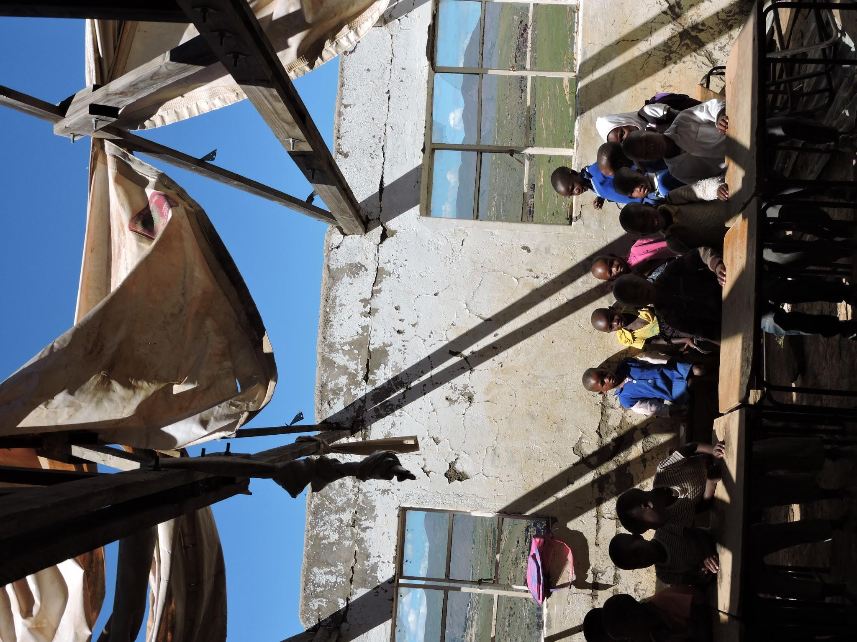

Our working days then ran to a similar pattern. We would wake at 6.00 (sunrise), light streaming through the window, and later through the door when that came off its hinges. Buckets of hot water were brought down for us to wash bodies and clothes in. Breakfast followed, then loading up the necessities into whatever transport option was available for that day. (Generator, clippers, coolbox with vaccine, drugs and surgical kit). On arrival at the nominated village we would “set up shop” and wait. February 7th was, unfortunately, a quiet day as our visit coincided with a massive initiation ceremony (Makoloane) for the young men (18-21) the culmination of 3 months living in the hills following their ritual circumcision. The community were very much occupied with festive preparations and partying, having very little interest in distractions like animal health that day! The villages we visited were: Ha Mohlokoane, Ha Muso, Ha Phafoli, Seboretlane, Ha Jopo, Ha Mokotso, Ha Emile, Hloahloeng and Pitsaneng.

Makoloane ceremony
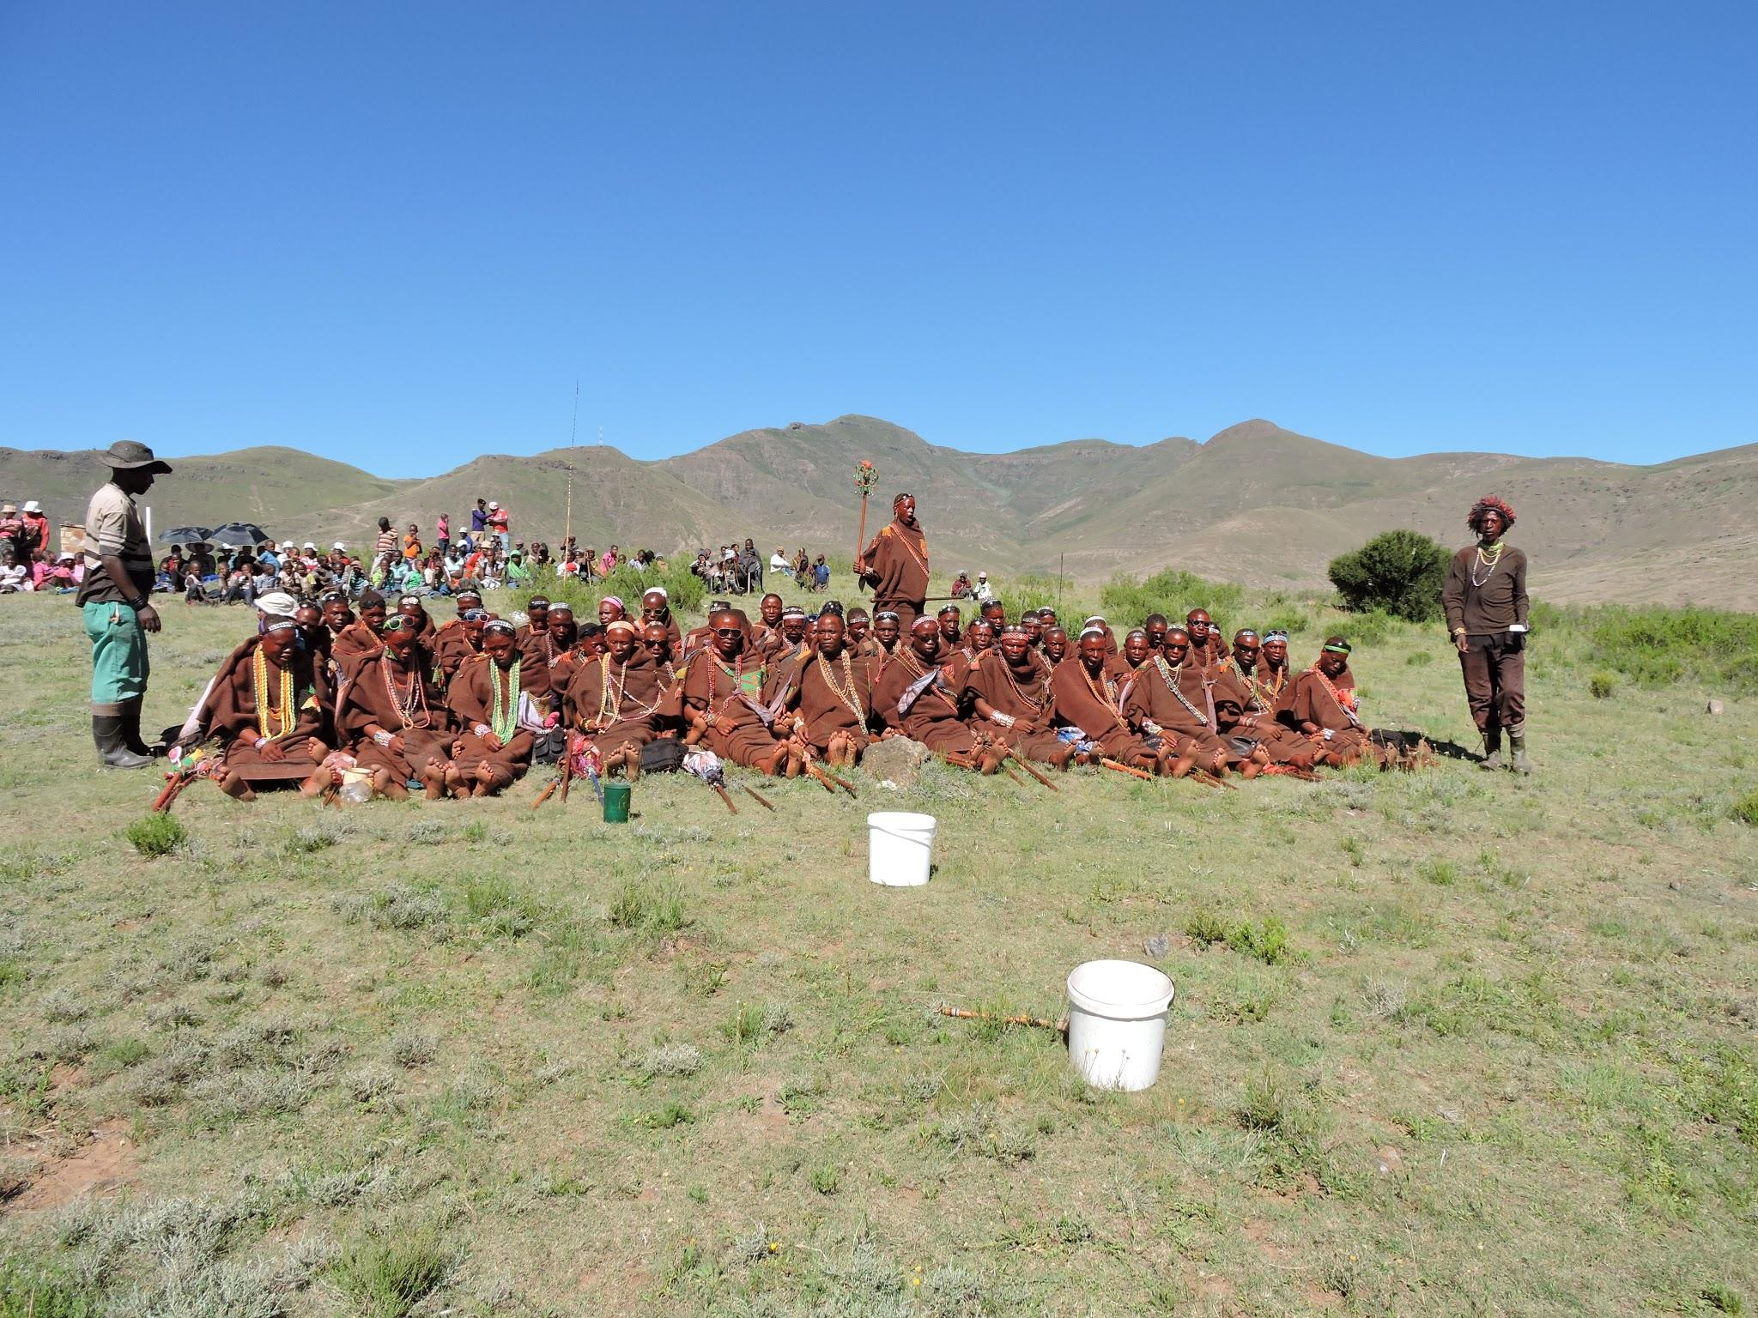

The services we offered were:

- Routine neutering for dogs and cats
- Rabies vaccination for dogs and cats
- Vaccination for dogs against distemper etc
- Internal parasite treatment for dogs and cats
- External parasite treatment for dogs and cats
- General animal health care and advice

For 5 days we were joined by an inspector and farrier from Highveldt Horse Unit (funded by World Horse Welfare) and during that period we were also able to offer horse and donkey castration.
Each animal which had surgical intervention was given analgesia and antibiotic cover.

In the event there was no evidence of a stray animal population in the area. All animals encountered were owned animals and it is unlikely that a stray without food or shelter would survive long in the harsh environment. Several owners stated that they did not want their cat neutered because they made money from selling the kittens. Neutering female animals is a totally unfamiliar concept in this society so there was a tendency to be anxious about carrying out this novel procedure. When the villagers saw animals being anaesthetised they expressed concern that they were dead as the concept of anaesthesia was also novel, due to this Lekena had a great deal of persuading and explaining to do.

Male animals were a different story, we came across significant numbers which had already been neutered, obviously fully conscious and without the benefit of anaesthesia or analgesia. These animals when restrained were always extremely nervous, struggling and vocalising in terror…There were also a number which had been subject to mutilation, cutting of ears, tails and tongues - cats ears were tipped in the belief that it would stop them straying (though not neutered!?) pigs tails were cut in the belief it would make them fatter ( females ?!) and the “worm under the tongue” was removed in some animals to make them fatter. Many animals had ears cut to identify them. Obviously all these mutilations had been performed on a fully conscious animal with no access to analgesia. One presumes that the myths surrounding these practices had come in part from the west without a full understanding of why, for example, tail docking may be practiced on a pig.

Vaccination is a familiar concept and Rabies is endemic in the country so we had good uptake for this, each vaccinated animal was also treated for internal and external parasites.

Patients arriving
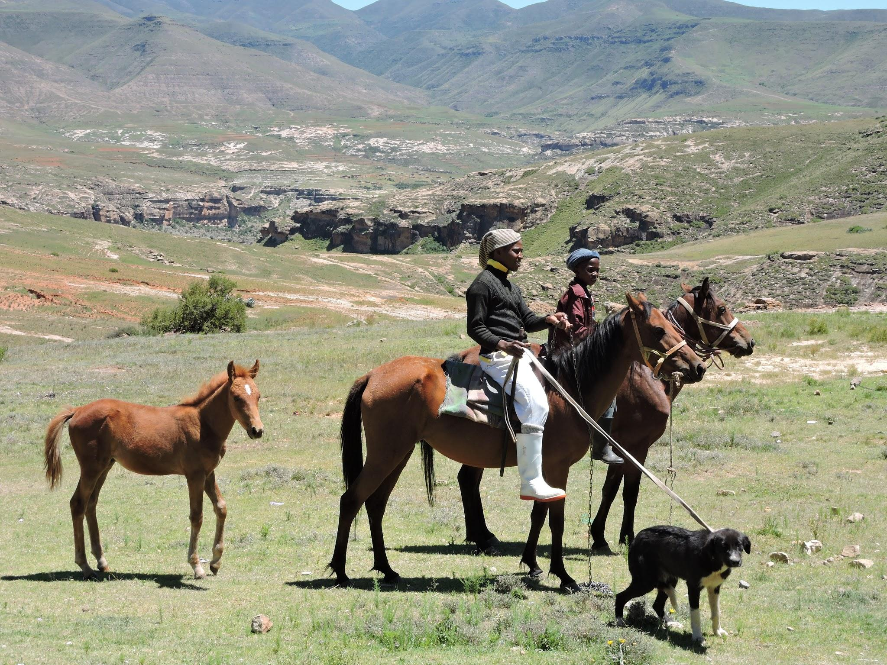

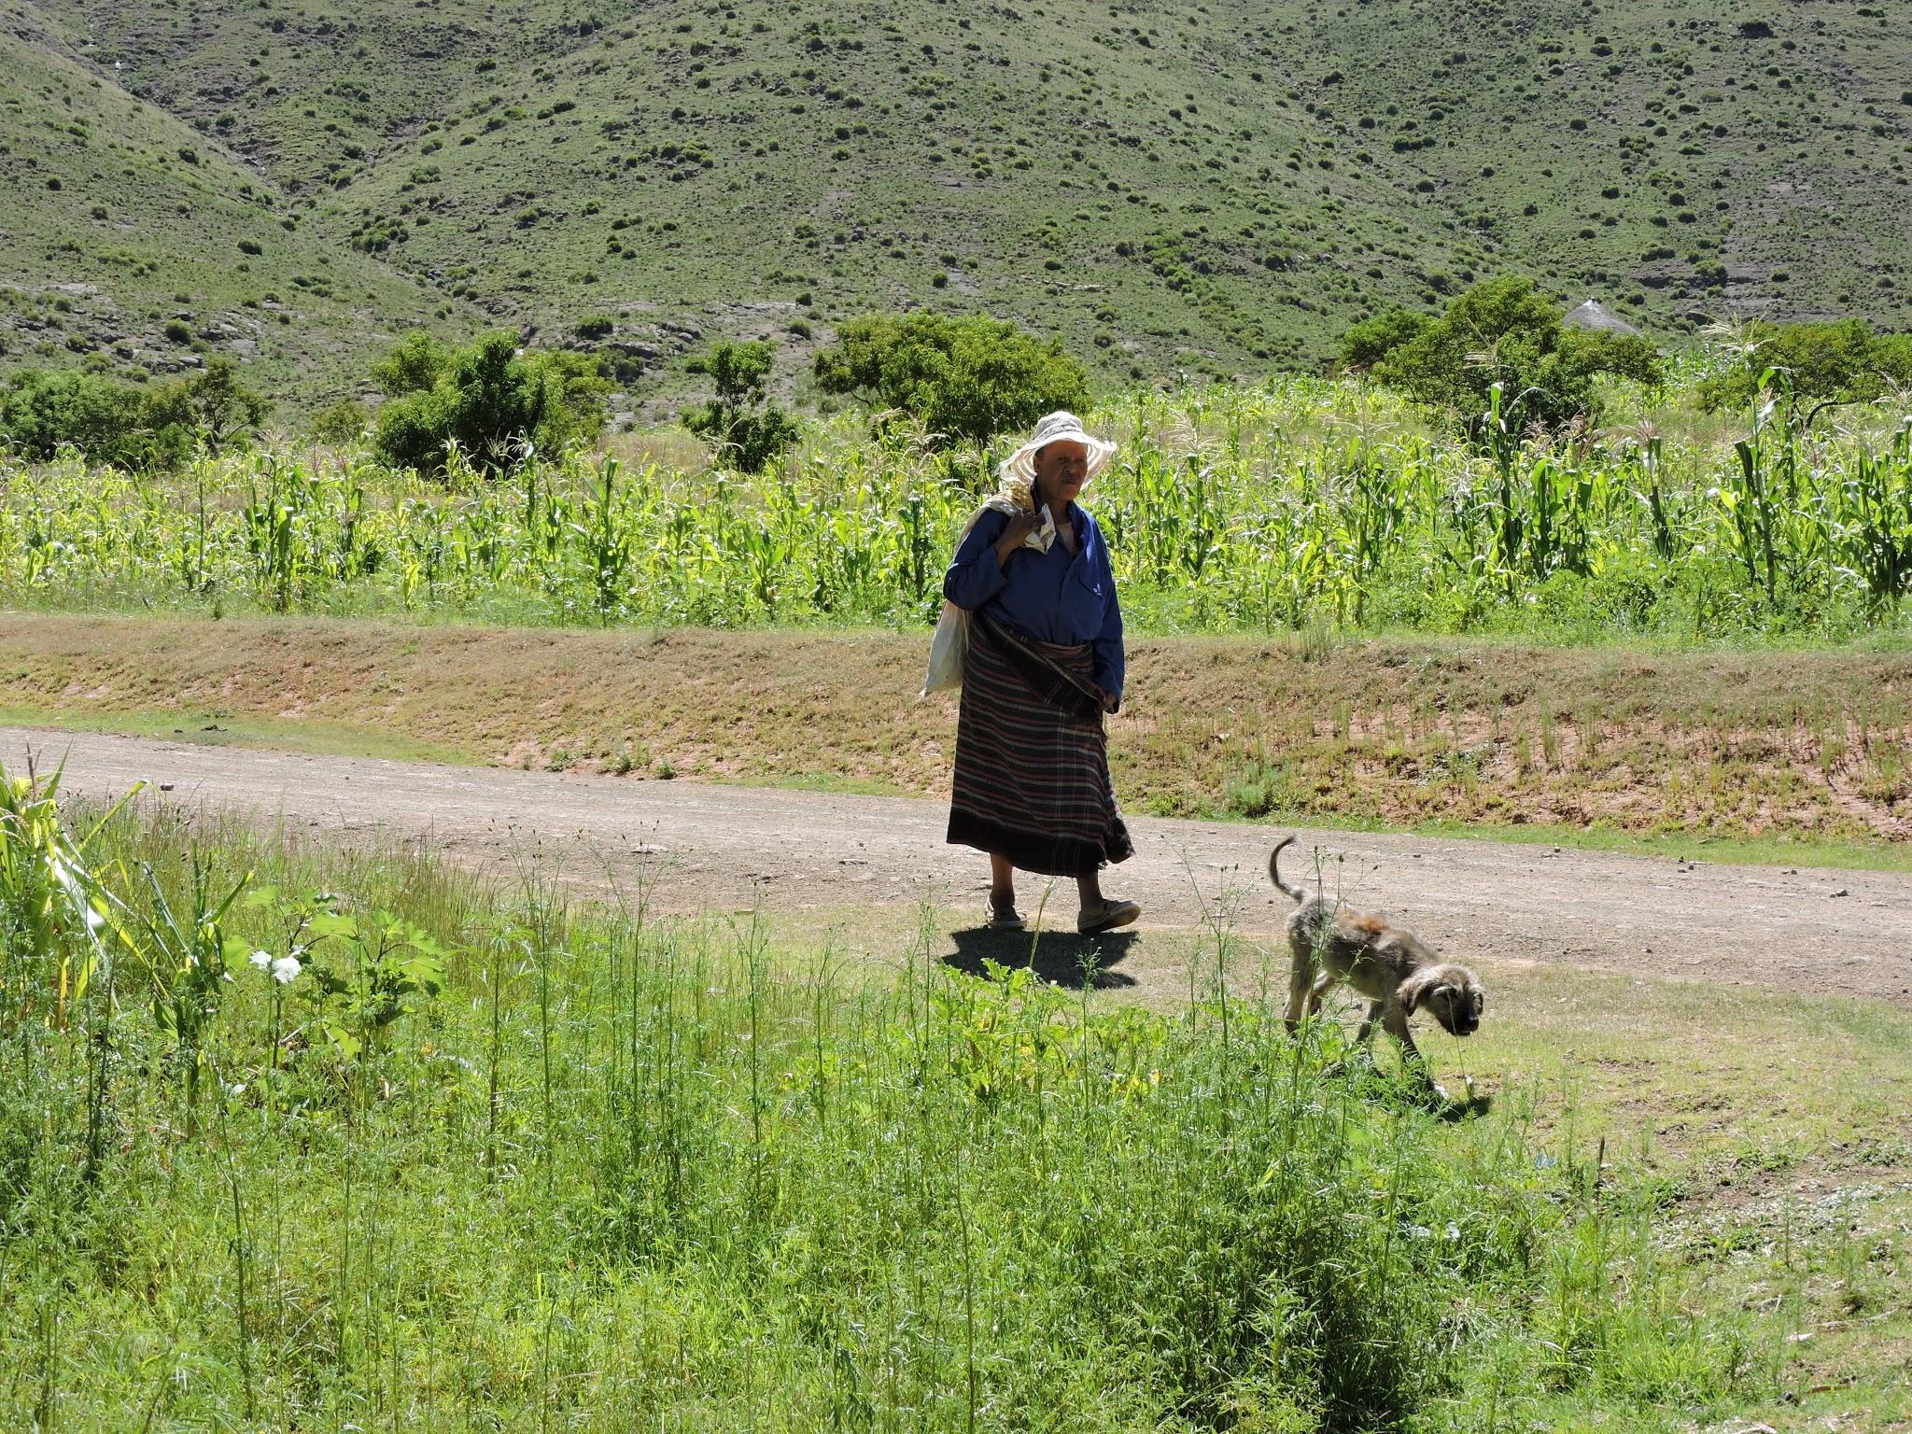
The animals would arrive as word got around of our arrival. Cats in empty maize meal sacks and dogs padding behind their owners, rarely on leads. We would then have a burst of activity, adapting to the challenging working conditions as best we could. Pickup tailgates, stone walls and grassy banks all became improvised operating tables. The sun was powerful and merciless, shade not always easy to find in such a deforested area. Flies (including large numbers of unappealing Hippoboscid “flat flies” on many dogs), breezes flapping the operating drapes, lack of access to clean water and electricity all presented challenges. None of the villages had electricity so Lekena provided his generator to power the clippers. Most villages had a stand pipe for water but not all, so we also carried our own water. We have asked PWA to monitor closely for any post-op complications and report back, as it was difficult to achieve optimum sterility in such conditions. I also had concerns that wound healing and recuperation may be compromised in animals on such marginal planes of nutrition, with little access to protein, as was typical for the animals we dealt with.

Operating
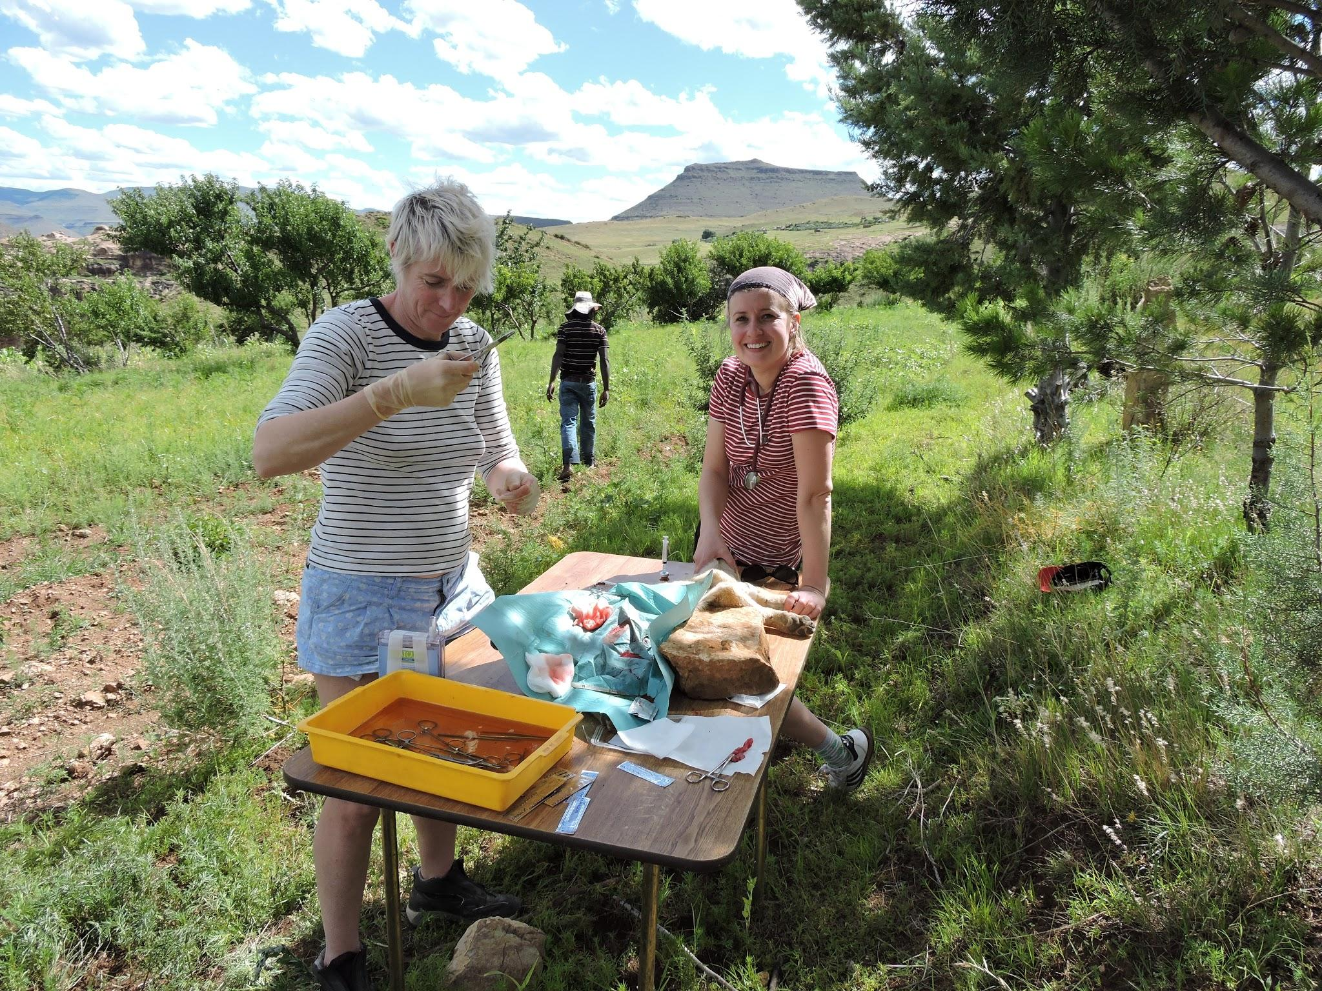

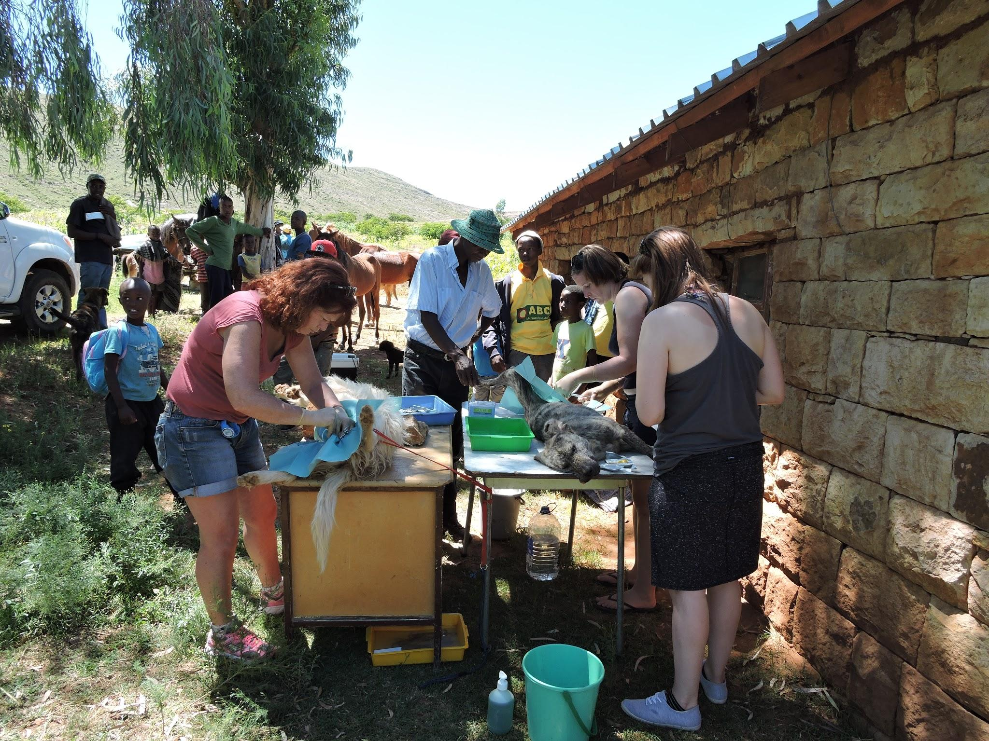

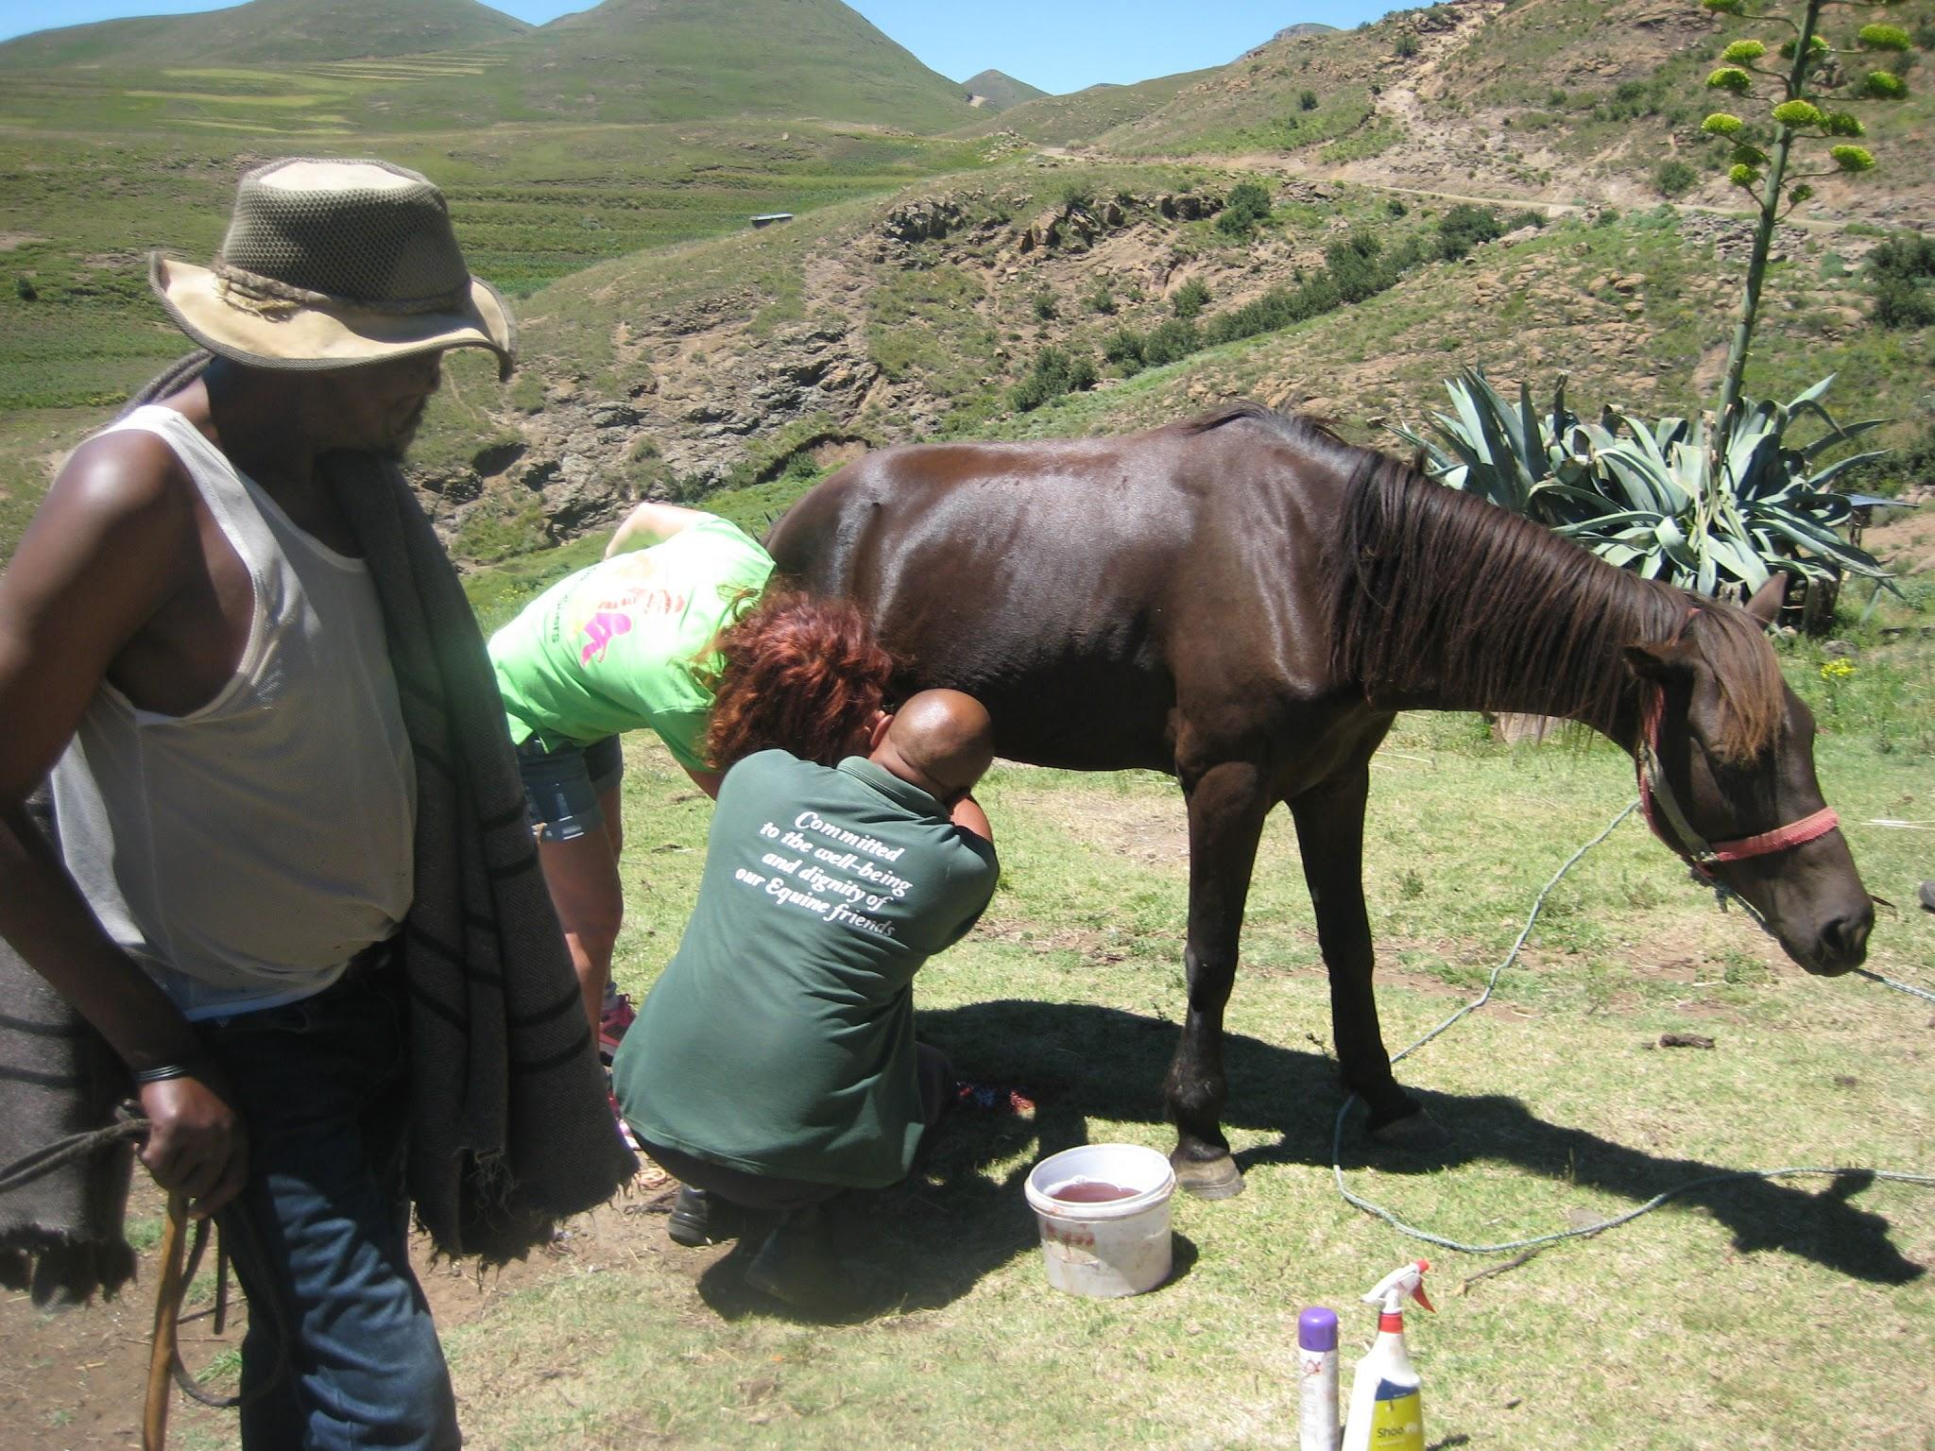

Animals recovering after surgery
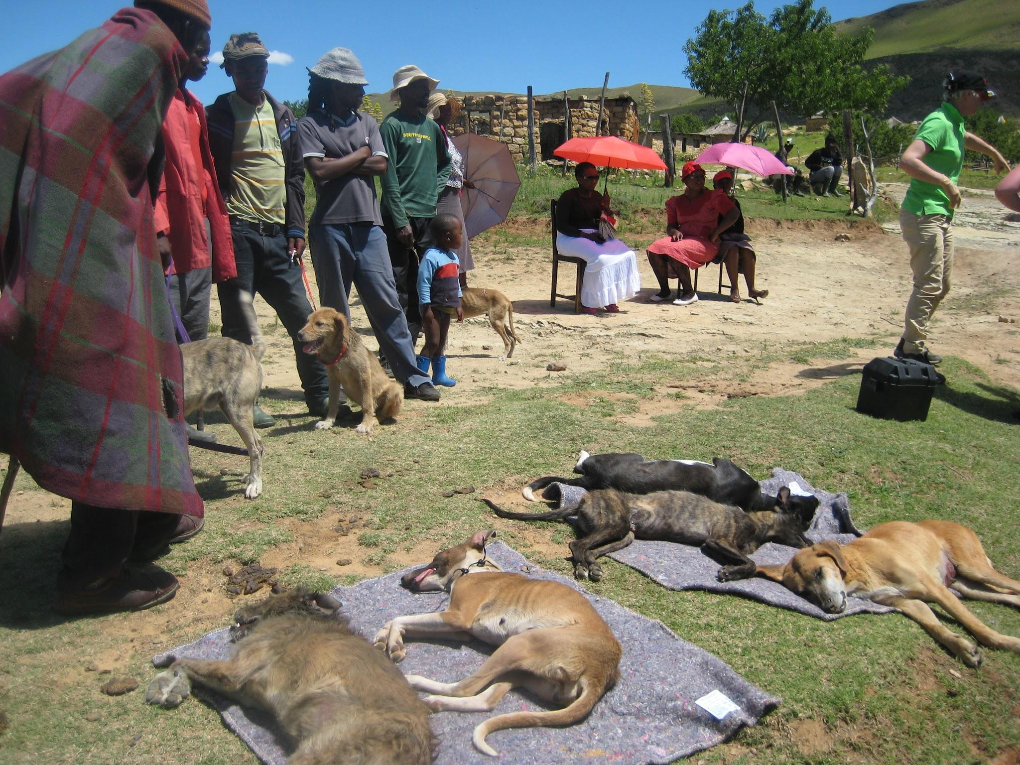

For 4 days we were joined by Solly and Samson, trained by Highveld horse unit and funded by World Horse Welfare. They work as a mobile unit, providing a farriery and basic horse healthcare service. In this area (where 80% of the conversation is about the horse) there was keen uptake for their services and they did a really marvelous job. As well as tick and worms Solly had many wounds (tack sores and rain scald the primary causes) and foot abscesses to treat. We had arranged for them to bring the necessary equipment to enable us to perform horse castrates so we were able to castrate horses and donkeys, until the supply of drugs was exhausted.

When the supply of animals dried up for that village we would pack up and move on. At the end of the day we would return to an invigorating shower from the irrigation hose which provided a convenient non stop supply of water streaming off the hillside. Bedtime was early as with no electricity other than the fuming hiccuping generator we tended to be in bed by nightfall. When our host learned that one of us was a vegetarian he employed Tabitha, a nutritionist, to help with meal planning and cooking for our party. This lady received the princely sum of 100 Rand per day (approx 6 pounds Sterling) for her work. Her home and family were nearly 200kms away in the capital, Maseru so she had to live in. Her usual employment is advising new mothers on good infant nutrition but she explained that nowadays there are not even the materials available for demonstrations, and the new mothers rarely have the resources to purchase the nutritious ingredients required to put the advice into practice.

Our “long drop” toilet was perfectly clean, but smelt more noxious each day (each person in the group succumbed to gastroenteritis at some point during their stay). Fortunately the toilet was situated a good distance downwind of the bedroom!

One day was also spent at the local school talking to the children about anatomy, physiology and animal welfare. I also compiled a presentation on animal welfare which Lekena is reviewing and translating.

Children listening to a dog’s heart
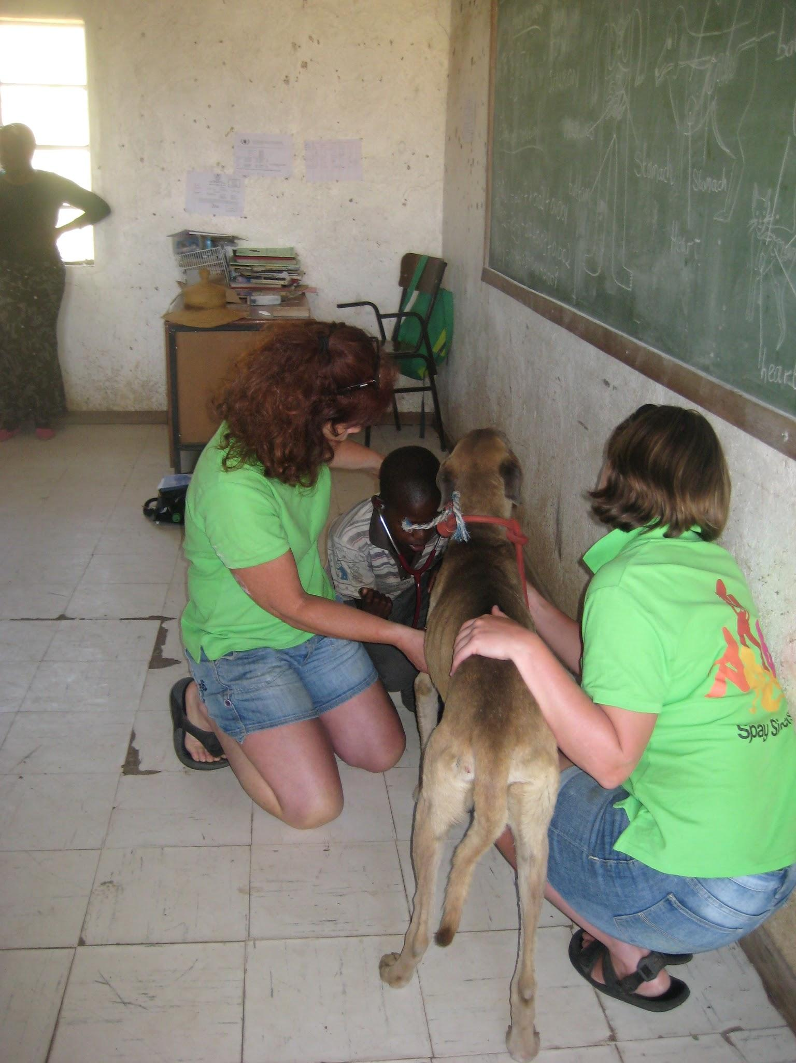

Every part of the land accessible to cultivation was in use. Women can be seen working the fields (“masimo”) with “Hlaola” (hoes) and hand-ploughing with oxen was the norm. I did not see a single tractor. The crop fields were a mix of maize (principal crop), beans and sorghum. Most households have some fruit trees, mainly peaches, some apple. Squash, tomatoes and pumpkin are also grown. Herds of sheep goats and cattle tend to be taken to pasture often on higher, less accessible ground and looked after by herdboys who sleep in the sheepfolds and cattle posts literally “watching the flocks by night”, accompanied by their dogs. An “average” household will own in the region of 30 sheep,15 goats, 5 cattle, 2 horses, 3 donkeys 3 dogs and maybe one or two cats, pigs and chickens. “Rich people” will own greater numbers of cattle and sheep, “poor people” own no animals.

Access to healthcare is difficult, the nearest clinic is a 2 hour walk away, 1 hour even by car accounting for the rough dirt tracks to be traversed.

Positive outcomes

This is a community that depends on animals of all species, therefore positive contact which brings health and welfare benefits to animals is required and appreciated. This very isolated community craves innovation and communication and there is a great deal to be done to bring benefit to the area in respect of animal healthcare. This project has started a process to further animal health and welfare in the Quabane area. It will be important to progress in a culturally sensitive manner with good communication and education at the forefront.

The final tally of animals helped by the end of the visit was:
Dog castrates:37
Bitch spays:30
Cat castrates:10
Cat spays:7
Horse castrates: 10
donkey castrate: 1

All the above received Rabies vaccinations and treatment for internal and external parasites.

In addition a further 178 dogs and cats received rabies vaccines and treatment for ecto- and endo- parasites. All dogs additionally received Vanguard multivalent vaccine for distemper, leptospirosis etc, kindly donated by Pfizer.

1 sheep was treated for respiratory disease. 1 puppy with pyoderma and malaise and a dog with an abscess were also treated. Two long haired dogs with extremely matted coats were clipped out and treated for parasites/skin irritation.

Clipping to treat skin problems
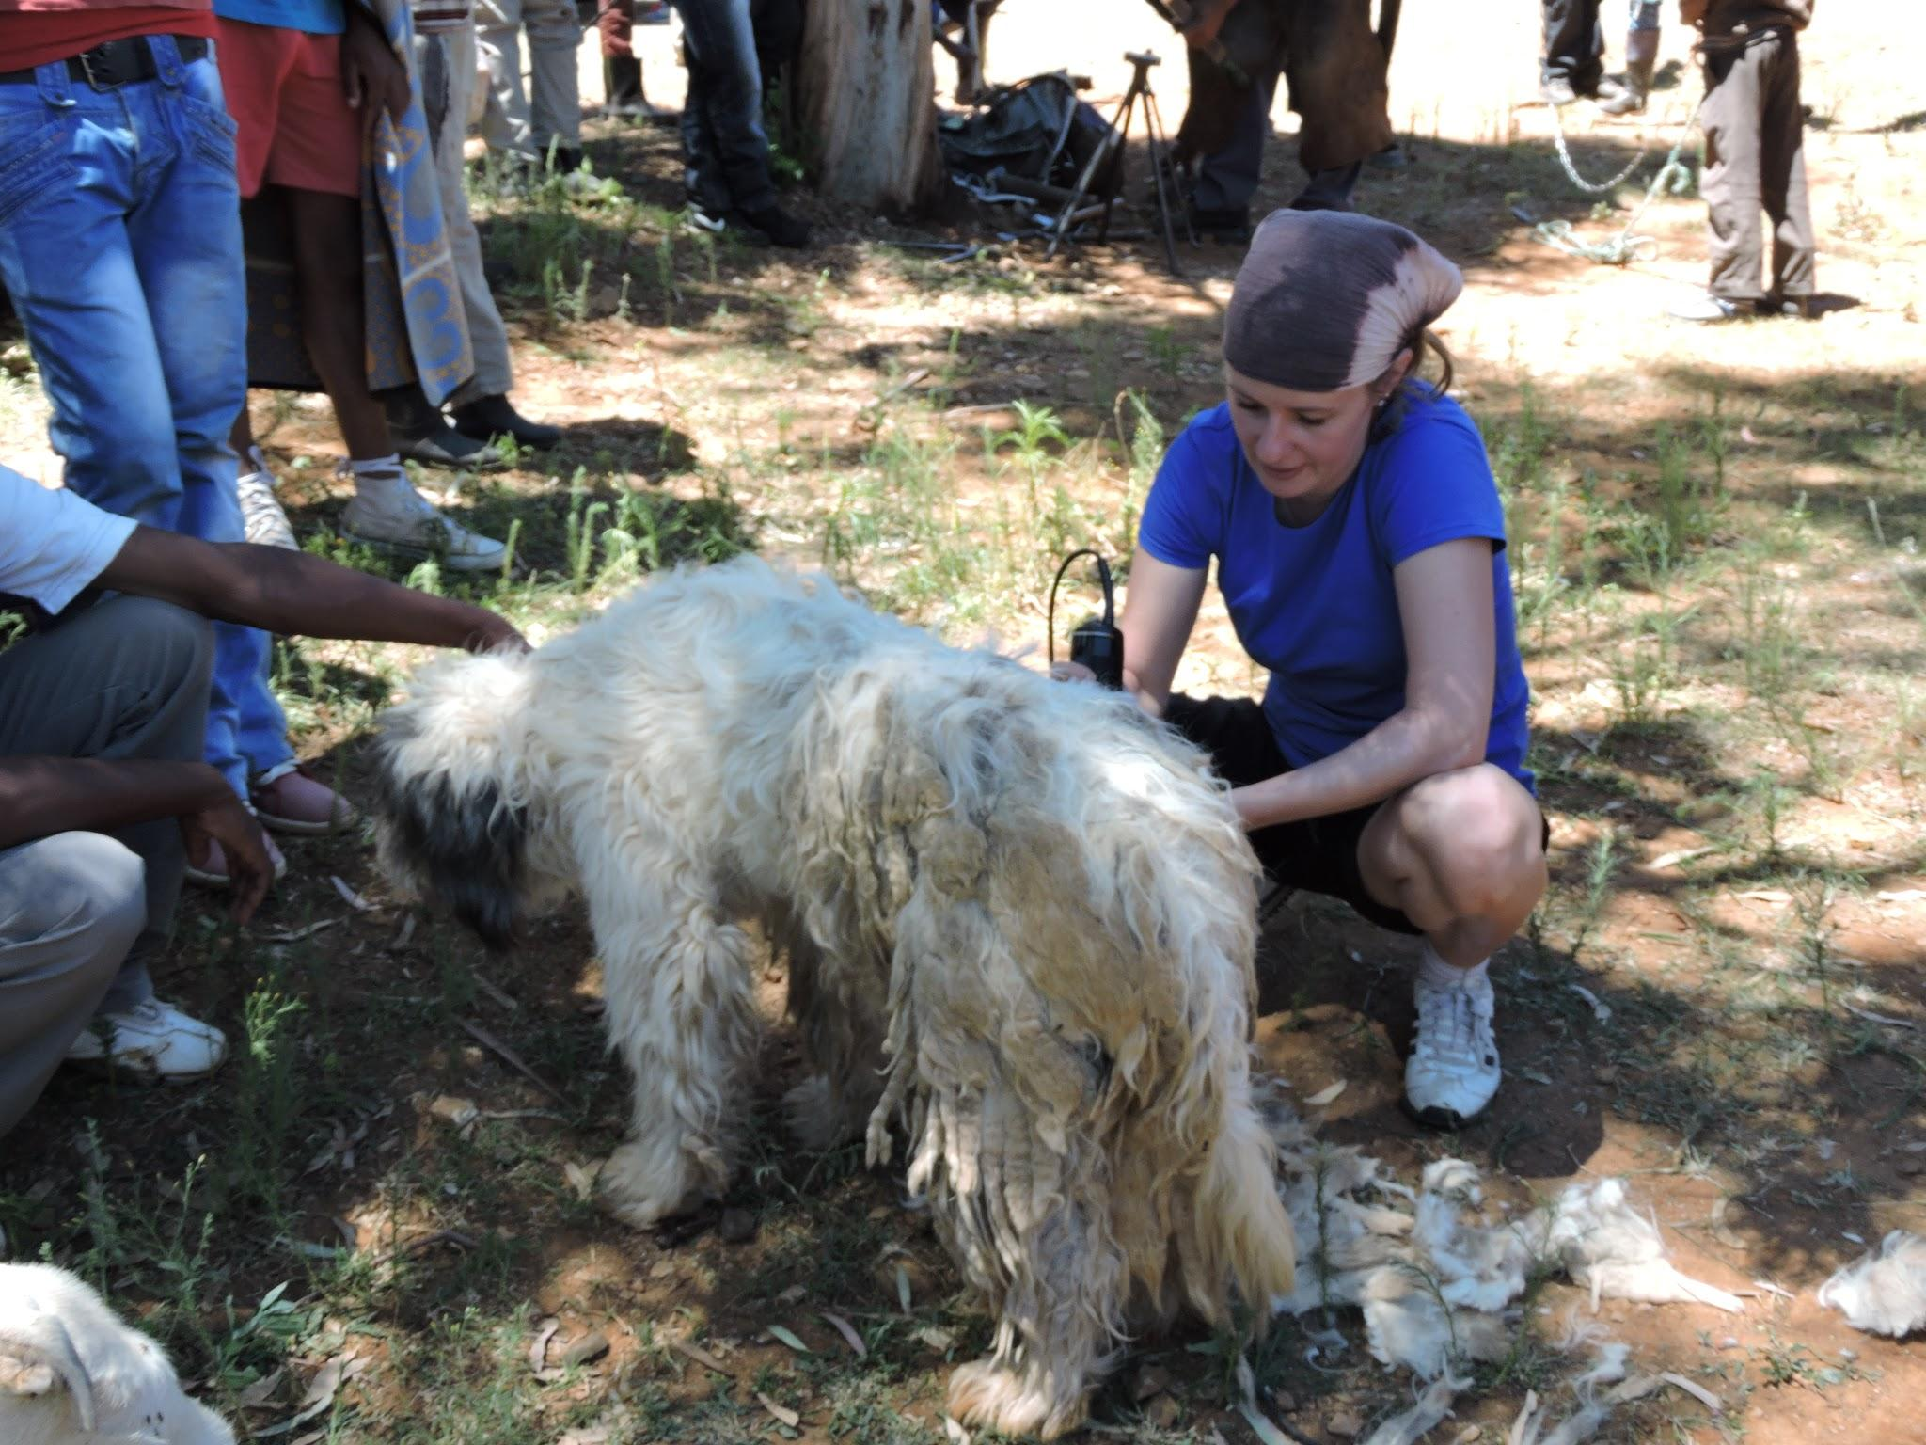

Appendix
Plants for medicinal use (Anecdotal. Source Lekena Bereng)
1)Hloenya. A tuber which is dug up, dried and crushed . For vomiting and gall bladder.
2) Aloe. Squeeze the juice into water for stomach upsets
3) African potato. used for high blood pressure or stomach upsets
4) Pooho-Tselha. Leaf is used for Diarrhoea or headache
4) Moretale. another tuber, used to treat nausea. Mix with
6) Lily root given to dogs with poor appetite
7) Sefoto-Fotha. Sucked
8) Koena. Leaf used as an infusion for fever
9) Phote ea Ngake. For coughing
10) Seboka. For eye infections
12 Lesoko. Coughing (not found growing in Quabane district)
13) Moriri oa matique. For piles!
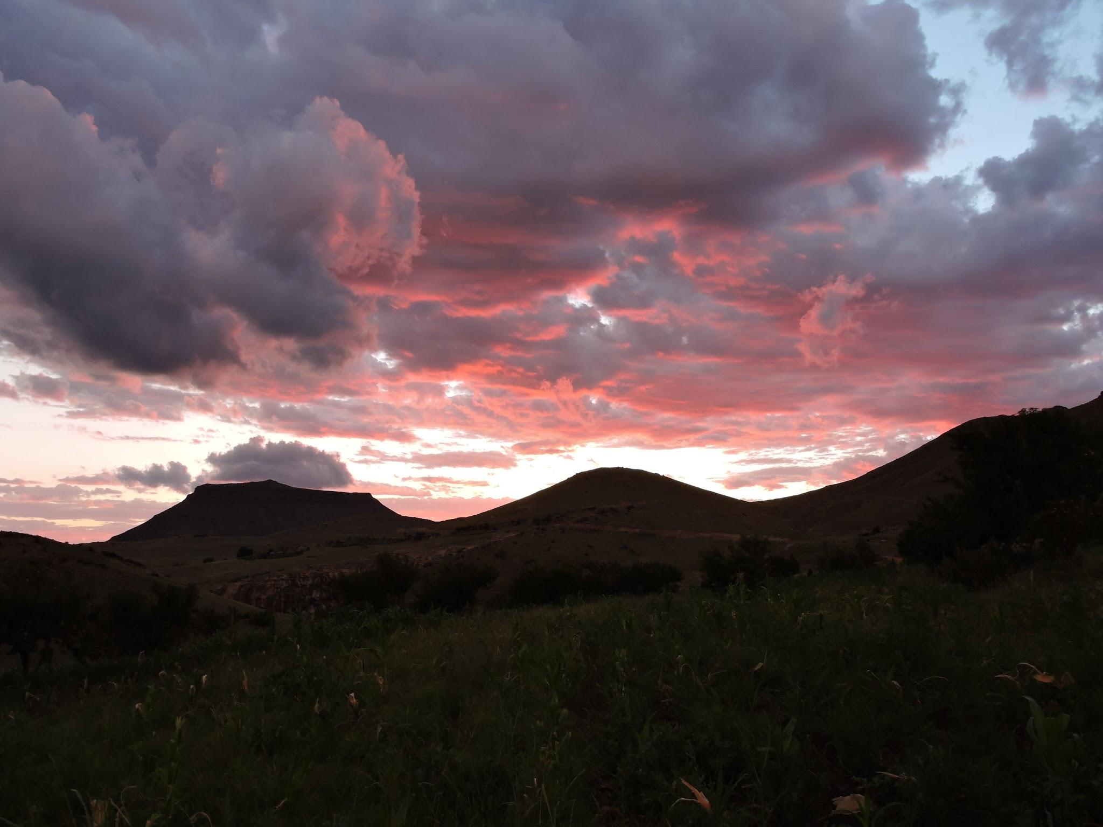

Sarah Morgan
March 2015

